Name: Abdullah
Mark: ________/50

1. Brief Introduction __/3
This document describes the Level Design and Level Progression System for the game. My feature includes the design and system control of Level 1 (Witch’s House Dungeon) and Level 2 (Jungle Escape Area).
The Level Design system manages environmental structure, trigger zones, boundaries, checkpoints, collectible items, and level transitions. In Level 1, the player must collect the pineapple and escape the dungeon while remaining in stealth mode. Collecting the pineapple sets a progression flag that informs the Enemy AI system. In Level 2, the player must escape through a jungle environment and enter a portal to transition to the final level.
Player progression data is encapsulated within a PlayerProgressState object used for checkpoint restoration.

2. Use Case Diagram with Scenario __/14
Actors: Player
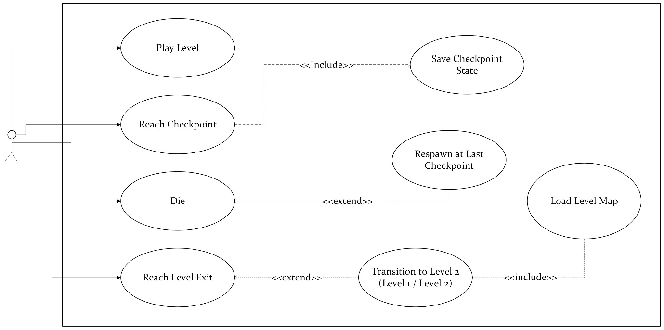

Scenario 1: Complete Level 1 (Witch House)
Name: Complete Level 1
Summary: Player explores a dungeon-style house, collects the pineapple, triggers enemy alert, and escapes through the hidden exit.
Actors: Player
Preconditions: Level 1 is loaded and player has spawned at start checkpoint.
Basic Sequence:
- System loads Level 1 layout, boundaries, rooms, enemies, collectibles, and checkpoints.
- Player explores rooms while avoiding detection.
- Player triggers Checkpoint #1 (mid-house).
- Player collects the pineapple.
- System updates progression flag which informs the Enemy AI system.
- Player triggers Checkpoint #2 (after pineapple collection).
- Player finds the hidden exit door.
- Player steps onto exit trigger.
- System validates pineapple collection.
- If valid, system transitions player to Level 2.
Exceptions:
Step 2a: If player health reaches 0 → invoke Respawn at Last Checkpoint.
Step 9a: If pineapple has not been collected → transition is blocked; exit remains inactive.
Postconditions:
Level 2 loads and player transitions.
Priority: 1
ID: LD01

Scenario 2: Complete Level 2 (Jungle Escape)
Name: Complete Level 2
Summary: Player navigates jungle environment and enters portal to transition to Level 3.
Actors: Player
Preconditions: Level 2 is loaded.
Basic Sequence:
- System loads Level 2 jungle layout and boundaries.
- Player navigates jungle area.
- Player triggers Checkpoint #1.
- Player triggers Checkpoint #2.
- Player enters portal trigger.
- System transitions player to Level 3.
Exceptions:
Step 2a: If player health reaches 0 → invoke Respawn at Last Checkpoint.
Postconditions:
Level 3 loads.
Priority: 1
ID: LD02

3. Data Flow Diagrams __/14

Context Diagram
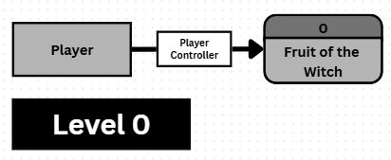

Level 0 DFD
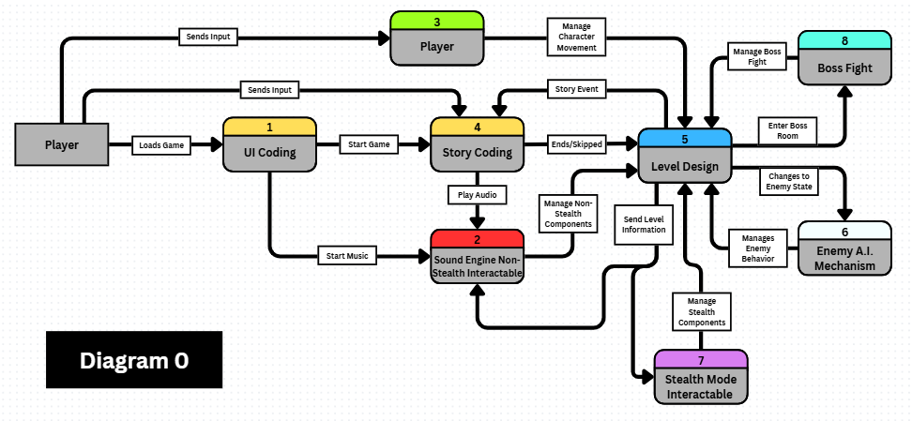
External Entities:
- Player
- Enemy AI System
- UI System
Process:
- Game System
Data Stores:
- Level Data
- Checkpoint Snapshot
- Progress Flags

Level 1 DFD
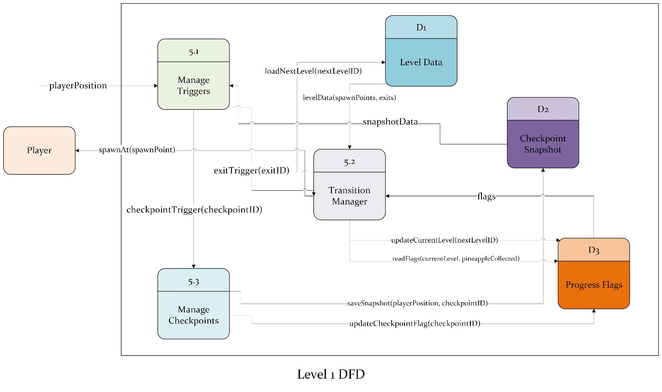
Processes:
5.1 Manage Triggers
5.2 Transition Manager
5.3 Manage Checkpoints

Data Stores:
- Level Data
- Checkpoint Snapshot
- Progress Flags (pineappleCollected, currentLevel)

Process Descriptions
Load Level
- Read currentLevel.
- Call appropriate loader (Level1Loader or Level2Loader).
- Load boundaries, trigger zones, checkpoints.
- Restore PlayerProgressState and spawn at saved progression position.

Manage Triggers
- Detect player collision with trigger zones.
- If pineapple collected → set pineappleCollected = true.
- Send alert event to Enemy AI System.
- If exit trigger activated → validate eligibility.
- If portal trigger activated → transition to next level.

Checkpoint Manager
On checkpoint trigger:
- Save PlayerProgressState (player position and progression flags).
- Save pineappleCollected state.
- Save level state snapshot.
On respawn:
- Restore PlayerProgressState snapshot.
- If pineappleCollected = true → enemy alert state remains active.

Transition Manager
- If Level 1 exit triggered:
- If pineappleCollected = false → block transition.
- If true → load Level 2.

- If Level 2 portal triggered:
- Load Level 3.

Failure Handler
If player health = 0:
- Load last checkpoint snapshot.
- Restore PlayerProgressState.
- Restore level state.
- Maintain enemy alert state if pineapple was collected.

4. Acceptance Tests __/9
Test ID | Description | Expected Result
AT01 | Level 1 loads | Player spawns correctly
AT02 | Exit without pineapple | Exit does not activate
AT03 | Exit with pineapple | Level 2 loads
AT04 | Pineapple collected | Enemy alert state activates
AT05 | Death before pineapple | Respawn at last checkpoint, no alert state
AT06 | Death after pineapple | Respawn at checkpoint #2, alert state remains
AT07 | Level 2 portal | Level 3 loads

Boundary Cases Covered:
- Exit trigger without requirement
- Death during alert state
- Missing checkpoint data (should default to level start)

5. Timeline __/10
Task | Duration (Hours) | Predecessor
Requirements Analysis | 6 | -
Level 1 Layout Design | 12 | 1
Level 2 Layout Design | 12 | 1
Boundary & Trigger Implementation | 10 | 2,3
Checkpoint System | 8 | 4
Transition Logic | 8 | 4
Testing | 10 | 5,6
Documentation | 6 | 7

PERT Structure:
1 → (2,3) → 4 → (5,6) → 7 → 8

Gantt Timeline:

PERT Diagram:
